**Name : Kunal Sachin Kharat**

**Roll no : 33**

**Batch : 2**

**Class : CSAIML-A**

**Q. Classical problems of synchronization**

**1.Producer-consumer problem:**

The producer-consumer problem is a classic synchronization problem in operating systems and concurrent programming. It involves two types of processes: producers and consumers, which share a common, fixed-size buffer or queue. Producers generate data items and place them into the buffer, while consumers retrieve and process these items from the buffer.

The main challenge of the producer-consumer problem is ensuring that producers do not produce items into the buffer when it is full, and consumers do not attempt to consume items from an empty buffer. This requires proper synchronization mechanisms to coordinate the activities of producers and consumers.

Typically, the solution to the producer-consumer problem involves the use of synchronization primitives such as semaphores, mutexes, or condition variables. These primitives are used to control access to the shared buffer and coordinate the actions of producers and consumers.

A common solution to the producer-consumer problem involves implementing the following operations:

**a.** **produce**: Producer processes generate data items and attempt to add them to the buffer. If the buffer is full, they must wait until there is space available.

**b.** **consume**: Consumer processes retrieve data items from the buffer and process them. If the buffer is empty, they must wait until there are items available.

**c.** **insert_item**: Operation to add an item to the buffer.

**d.** **remove_item**: Operation to remove an item from the buffer.

The synchronization mechanism ensures that producers and consumers coordinate their actions properly, preventing issues such as race conditions, data corruption, or deadlock.

Code :

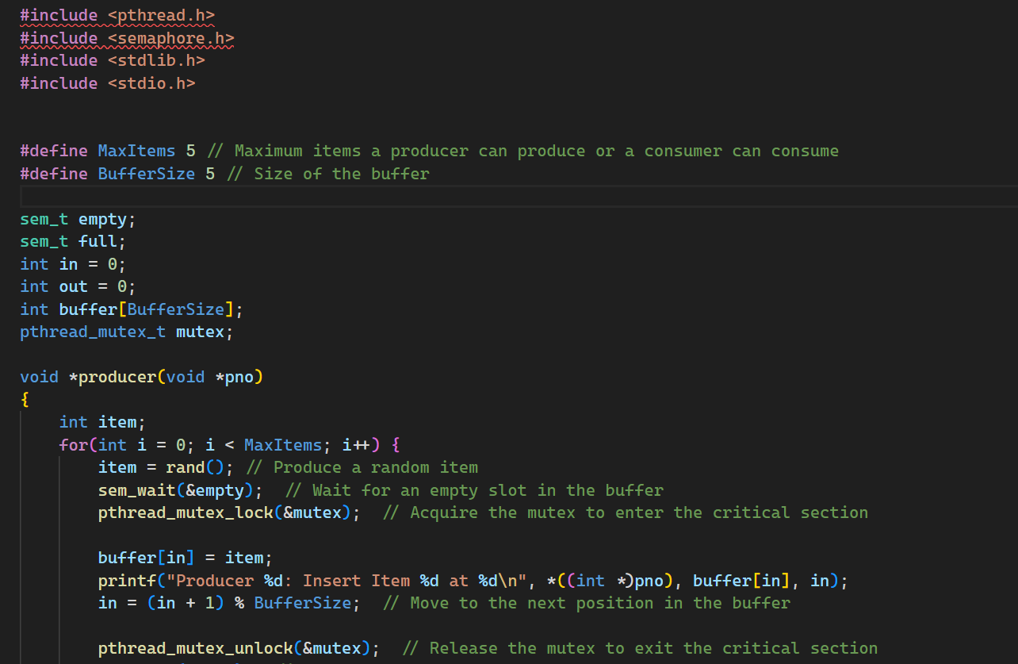

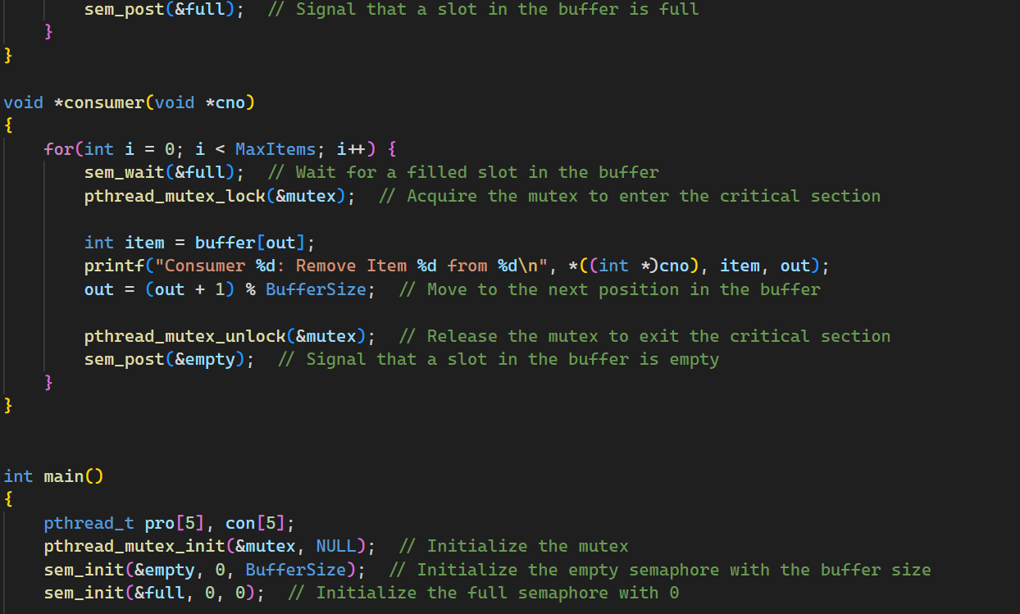

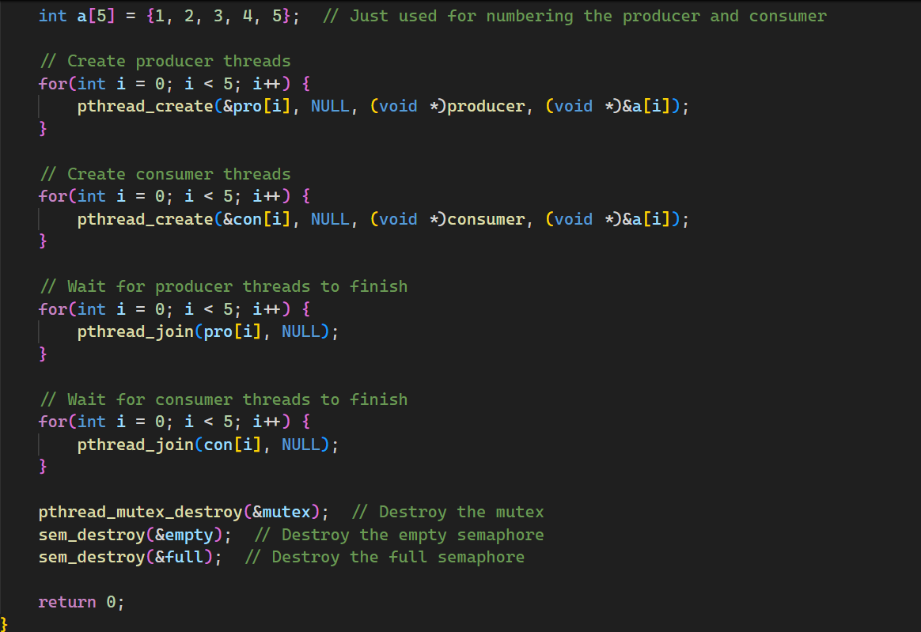

**Output:**

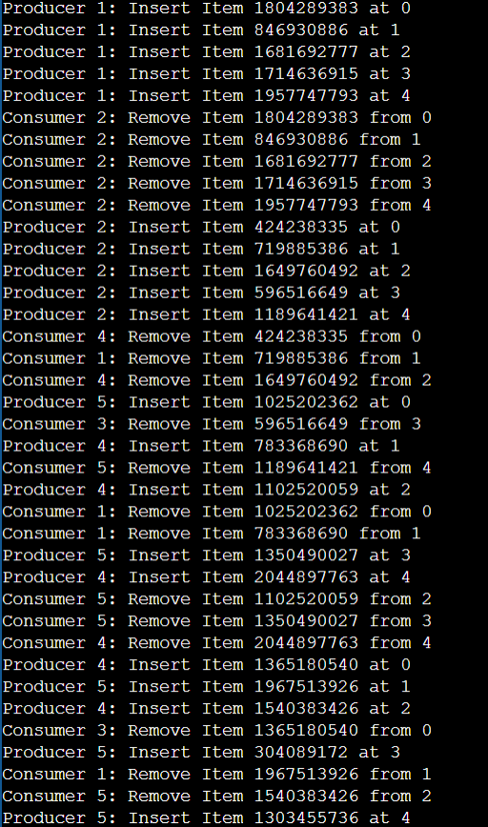

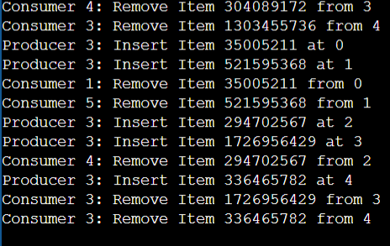

**2.Reader Writer Problem:**

The Reader-Writer problem is a classic synchronization problem in operating system design and concurrent programming. It deals with situations where multiple threads, known as readers and writers, access a shared resource, typically a data structure like a file, database, or memory location. The goal is to coordinate the access to this shared resource in a way that maintains consistency and prevents conflicts.

Here's a brief overview of the problem:

**a. Readers:** These threads only read the shared resource but do not modify it. Multiple readers can access the resource simultaneously without any issues because reading does not affect the integrity of the resource.

**b. Writers:** These threads modify the shared resource. When a writer is writing to the resource, it must have exclusive access to prevent other writers or readers from accessing the resource concurrently, as concurrent writing might lead to inconsistency or corruption of data.

The main challenge in the Reader-Writer problem is to ensure that:

Readers can access the resource simultaneously if no writers are writing to it.

Writers have exclusive access to the resource (i.e., no other readers or writers can access it) while they are writing to it.

Starvation and deadlock are avoided.

There are several solutions to the Reader-Writer problem, including using various synchronization primitives like mutexes, semaphores, condition variables, or implementing higher-level synchronization mechanisms like reader-writer locks. Each solution has its advantages and disadvantages in terms of fairness, efficiency, and implementation complexity. The choice of solution depends on the specific requirements and characteristics of the application.

Code :

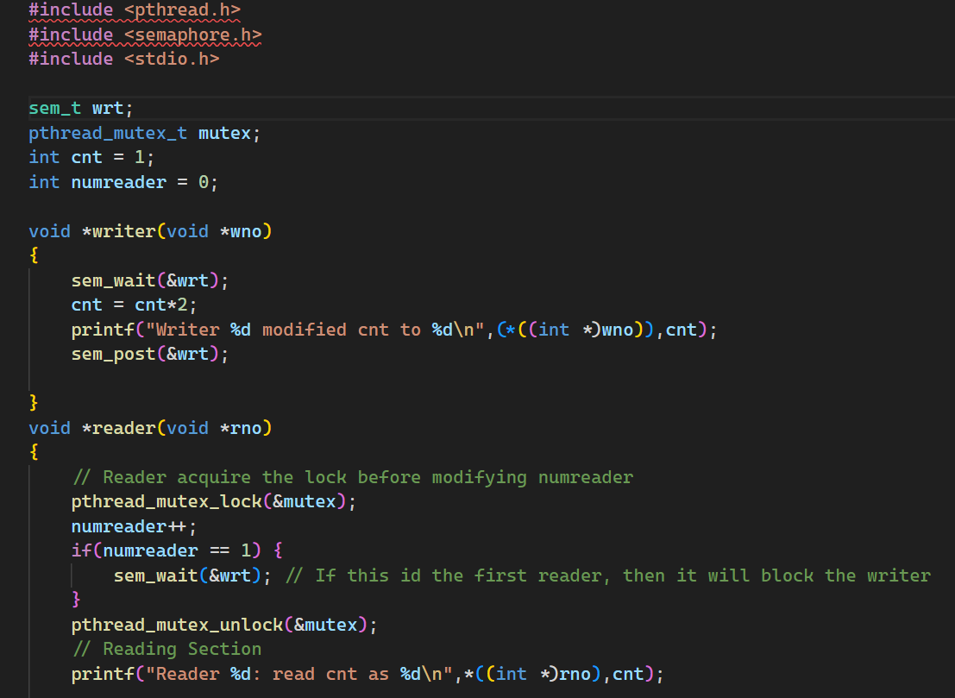

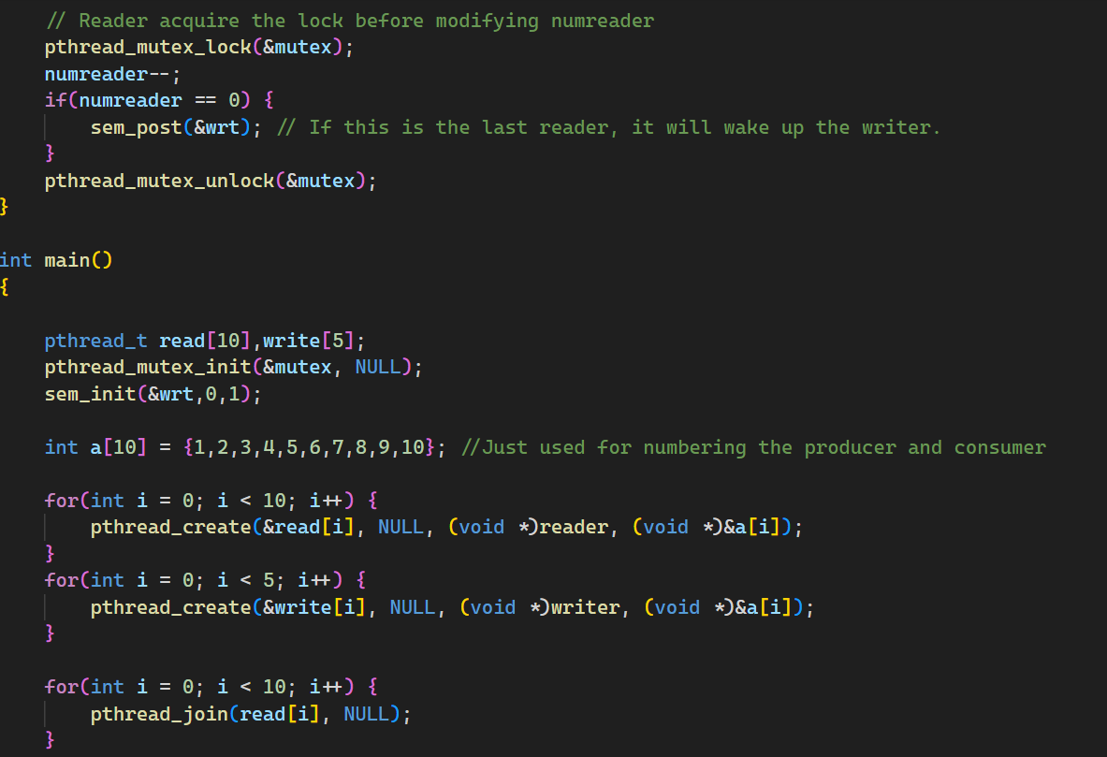

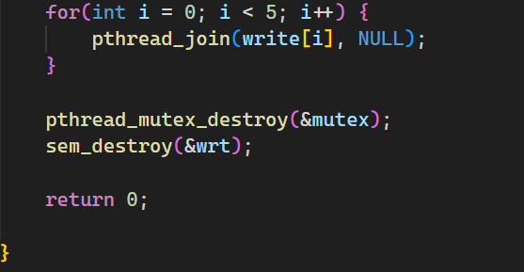

**Output:**

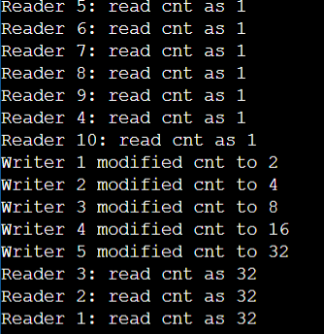

**3.Dining Philosopher Problem:**

The Dining Philosophers Problem is a classic synchronization problem often used to illustrate the challenges of deadlock and resource contention in concurrent programming. It was first proposed by Edsger Dijkstra in 1965.

The problem is formulated as follows:

There are five philosophers sitting around a dining table, and each philosopher spends their life alternating between thinking and eating. In the center of the table, there are five chopsticks, each placed between two adjacent philosophers.

The life of each philosopher consists of three activities: thinking, picking up chopsticks, and eating. To eat, a philosopher must pick up the chopstick to their left and the chopstick to their right. Once a philosopher has both chopsticks, they can eat. After eating, the philosopher puts down the chopsticks and resumes thinking.

The challenge arises from the fact that the philosophers must share the chopsticks, and thus they may compete for the same resources, potentially leading to deadlock or starvation.

To solve the Dining Philosophers Problem, synchronization mechanisms such as mutex locks, semaphores, or monitors can be used to ensure that the philosophers can acquire the chopsticks without causing deadlock or starvation. Various solutions have been proposed over the years to address this problem while ensuring that the philosophers can eat without getting stuck indefinitely. These solutions typically aim to prevent deadlock by imposing certain rules or constraints on how the philosophers can pick up the chopsticks.

**Code:**

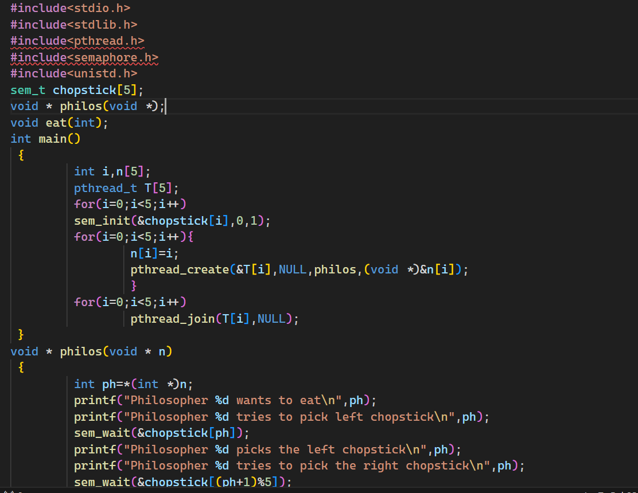

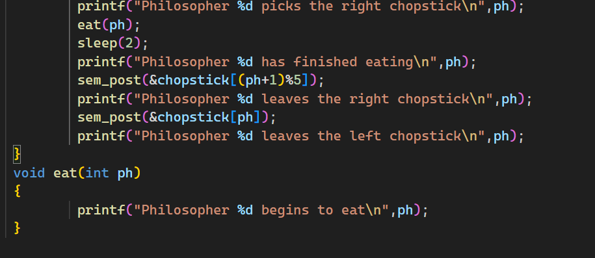

**Output:**

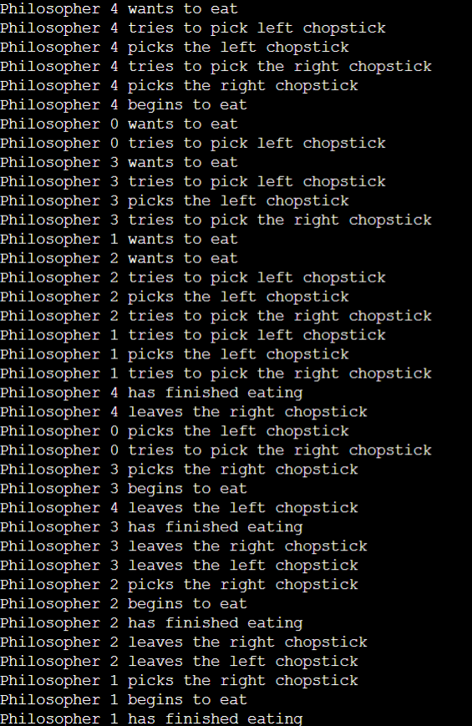

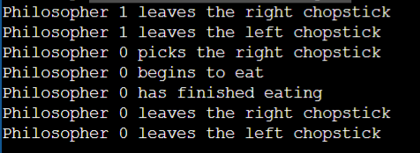

**Conclusion:**

In conclusion, process synchronization is a critical aspect of concurrent programming aimed at coordinating the execution of multiple processes or threads to ensure correct and efficient operation. Through mechanisms such as mutex locks, semaphores, and monitors, synchronization enables shared resources to be accessed safely, preventing issues like race conditions, deadlock, and starvation. Effective solutions to process synchronization problems are essential for building reliable and scalable software systems, ensuring that concurrent processes can cooperate harmoniously without interfering with each other's execution.